Standard | Items:
4.OA.04 -  Find all factor pairs for a whole number in the range 1–100. Recognize that a whole number is a multiple of each of its factors. Determine whether a given whole number in the range 1–100 is a multiple of a given one-digit number. Determine whether a given whole number in the range 1–100 is prime or composite. | 3.0  Please solve the following problems. (4.OA.4/3.0)  - List all of the factor pairs of 28.  ___________________________________________________________________  - What whole number has only these factors: 1, 2, 3, 4, 6, 12? ______________  - Is 28 a multiple of 7? ____________________  - Is 7 prime or composite? _________________________
2.0
- Circle the prime numbers.
  - 14
  - 2
  - 31
  - 58
- Find the factor pairs of 30.
- Which number is both a factor of 30 and a multiple of 5? a) 15 b) 45 c) 110 d) 140
- Is 28 prime or composite? How do you know?
4.OA.05 -  Generate a number or shape pattern that follows a given rule. Identify apparent features of the pattern that were not explicit in the rule itself. For example, given the rule “Add 3” and the starting number 1, generate terms in the resulting sequence and observe that the terms appear to alternate between odd and even numbers. Explain informally why the numbers will continue to alternate in this way. | 3.0  Please solve the following problems. (4.OA.5/3.0)  - Create a number pattern.  ___________________________________  B. Write your rule. _____________________  C. 1, 4, 7, 10, 13  1. What comes next in the pattern? ______  2. Describe another pattern you see.  ____________________________________________
2.0

- Look at the number list.
  - Extend the pattern: 4, 8, 12, 16, _____.
  - Complete the statement: The rule is_________________________.
4.MD.01 -  Know relative sizes of measurement units within one system of units including km, m, cm; kg, g; lb, oz.; l, ml; hr, min, sec. Within a single system of measurement, express measurements in a larger unit in terms of a smaller unit. Record measurement equivalents in a two- column table. For example, know that 1 ft is 12 times as long as 1 in. Express the length of a 4 ft snake as 48 in. Generate a conversion table for feet and inches listing the number pairs (1, 12), (2, 24), (3, 36), ... | 3.0 Complete the table. (4.MD.1/3.0)  Feet (ft.) Inches (in.)  1 12  2  36  2.0  Justify each answer.  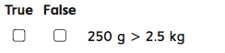  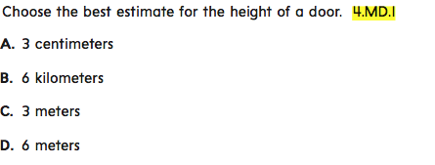
2.0
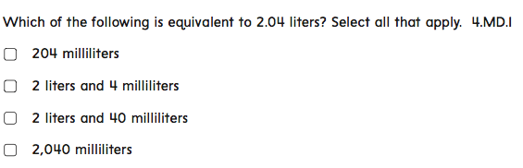
Show all your work.

Connect the related units of measurements:

inches |  | meters
hours |  | feet
ounces |  | pounds
kilometers |  | minutes

2.0

- 1 hour (hr.) = ______ minutes (min.)

- _____ kilograms (kg.) = 1,000 grams (g.)

- 1 pound (lb.) = ______ ounces (oz.)

4. 1 liter (l.) = ______ milliliters (ml.)

5. _____ meters (m.) = 100 centimeters (cm.)

6. 1 foot (ft.) = ______ inches (in.)

7. 1 minute (min.) = _____ seconds (sec.)

2.0

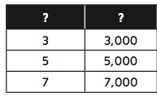
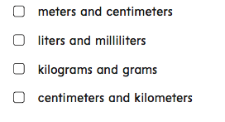
4.MD.04 -  Make a line plot to display a data set of measurements in fractions of a unit (1/2, 1/4, 1/8). Solve problems involving addition and subtraction of fractions by using information presented in line plots. For example, from a line plot find and interpret the difference in length between the longest and shortest specimens in an insect collection. | 3.0  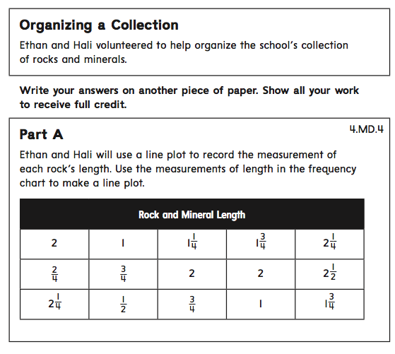  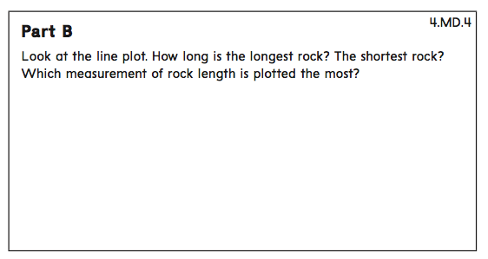  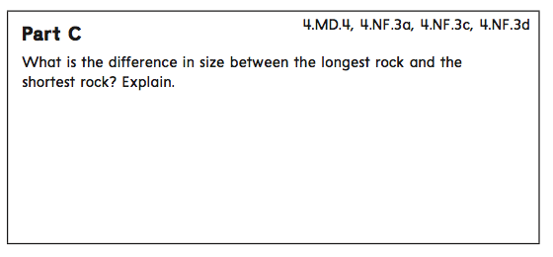
2.0

- Sam conducted a survey to see how much time each classmate spends per week playing video games. (4.MD.4/2.0)
    - Use Sam’s data to create a line plot. Make sure you include a scale for your line plot.
1 hour | 2 hours | 3 hours | 4 hours | 5 hours | 6 hours
4 | 2 | 6 | 7 | 3 | 2

How many classmates spent fewer than 2 hours a week playing video games?

4.MD.06 -  Measure angles in whole-number degrees using a protractor. Sketch angles of specified measure. | 3.0  Part A: Find the measure of each angle in the quadrilateral below.  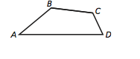  __________________________  Part B: Draw a 60° angle below.
2.0

- Measure angle A
A
- Draw a 60° angle on the protractor below. 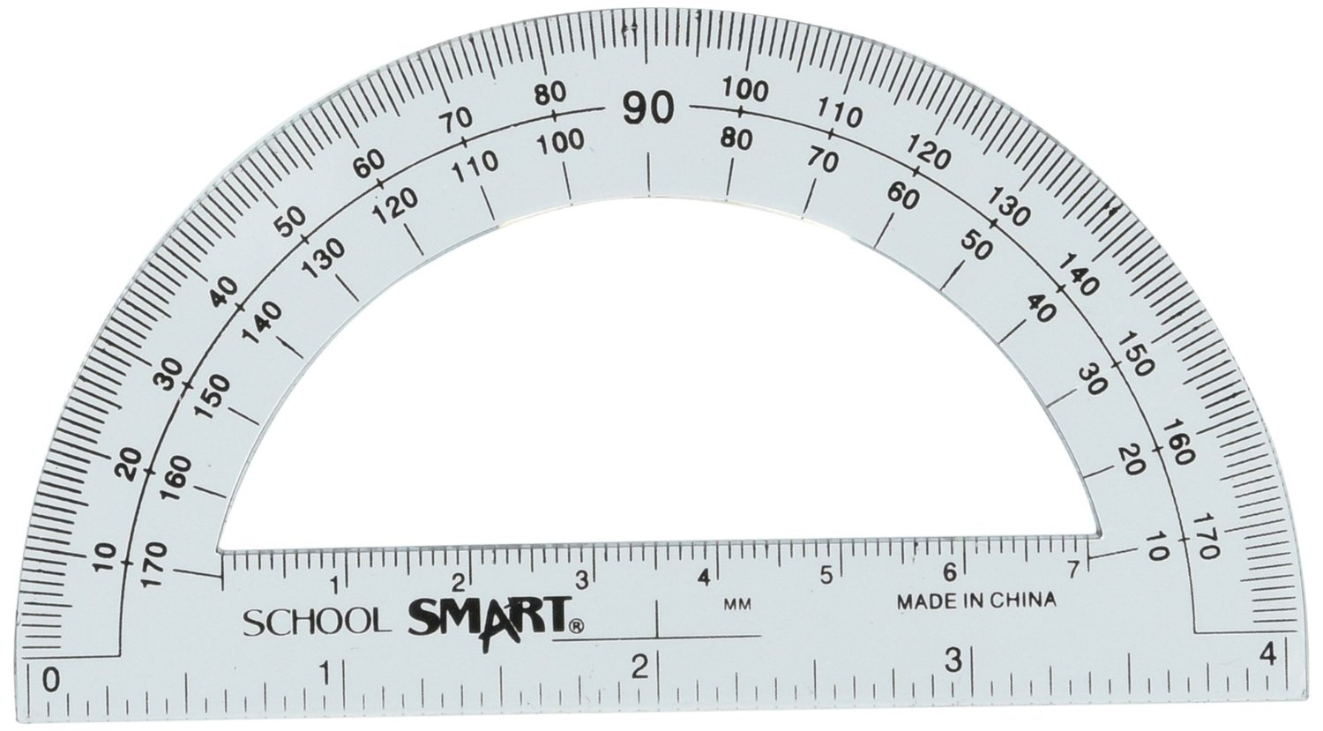

Standards: 4.NF.04 - Apply and extend previous understandings of multiplication to multiply a fraction by a whole number.  - c) Solve word problems involving multiplication of a fraction by a whole number, e.g., by using visual fraction models and equations to represent the problem. For example, if each person at a party will eat 3/8 of a pound of roast beef, and there will be 5 people at the party, how many pounds of roast beef will be needed? Between what two whole numbers does your answer lie? | 3.0  Solve the following word problem. (4.NF.4/3.0)  If each child gets 3/8 of a pound of clay, and there are 5 children, how many pounds of clay will be needed?  Show your work below:
2.0
Solve the problem below. (4.NF.4/2.0)
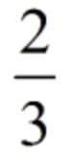x 4 =
Standards: 4.NF.5  Express a fraction with denominator 10 as an equivalent fraction with denominator 100, and use this technique to add two fractions with respective denominators 10 and 100. | 3.0  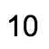  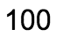  3 + 4 = ________  2.0  2 = __ __
Standards: 4.G.01 - Draw points, lines, line segments, rays, angles (right, acute, obtuse), and perpendicular and parallel lines. Identify these in two-dimensional figures. | 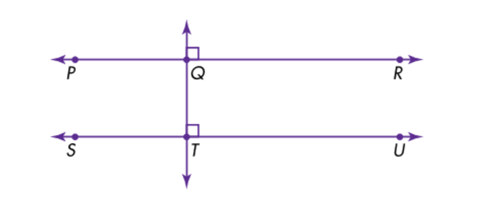  3.0  Use the diagram to the right to:  A. Name one line segments.  B. Name one ray.  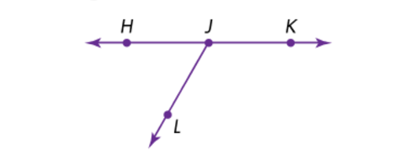  C. Name one right angle.  D. Name one acute angle.  E. Name one obtuse angle.  Draw the items below:  F. Draw two lines that are parallel. G. Draw two lines that are perpendicular.  H. Draw a point. I. Draw a line.  J. Draw a line segment. K. Draw a ray.  L. Draw a right angle. M. Draw an acute angle.  N. Draw an obtuse angle.
2.0

Write “parallel,” “perpendicular,” or “neither” for each pair of streets.

